1. Problem Statement

The "URL Shortener API" provides the ability to shorten long URLs into shorter

1. Requirement

Accept a long URL as input and return a shortened URL

Should accept only valid URL’s

1. Endpoint

Post hostname/api/Url/generateShortUrl

1. Flow diagram

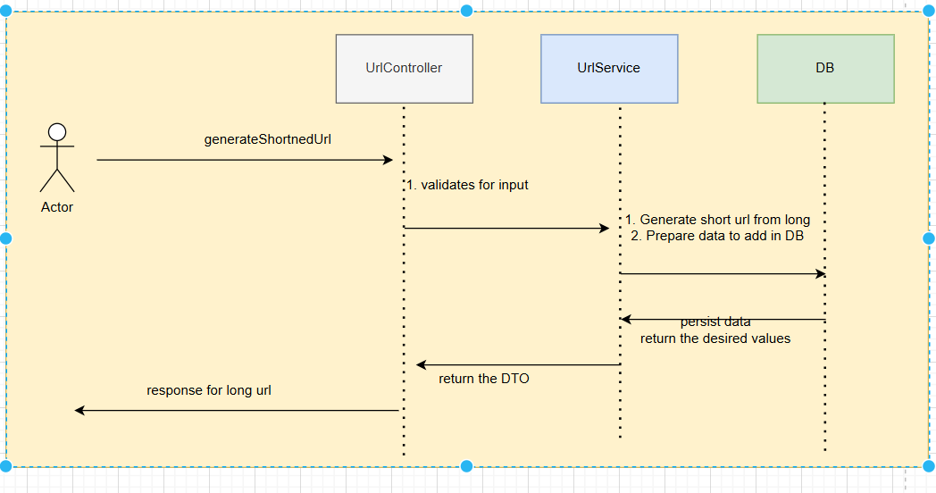

1. Example

Request :

Post host/api/Url/generateShortUrl

{

"longUrl": "https://www.perplexity.ai/search/asp-net-kv7L.FaiTjS5L.Fh10NgUg"

}

Response :

Body

{

"longUrl": "https://www.perplexity.ai/search/asp-net-kv7L.FaiTjS5L.Fh10NgUg",

"shortUrl": "newgen.ly4ldrhY"

}

1. Other